**DAILY ONLINE ACTIVITIES SUMMARY**

|  |  |  |  |  |  |  |  |
| --- | --- | --- | --- | --- | --- | --- | --- |
| **Date:** | **19-05-2020** | | | | **Name:** | **Laxminarayan Miskin** | |
| **Sem & Sec** | **4TH SEM A** | | | | **USN:** | **4AL18CS044** | |
| **Online Test Summary** | | | | | | | |
| **Subject** | | **DESIGN AND ANALYSIS OF ALGORITHM** | | | | | |
| **Max. Marks** | | **30** | | **Score** | |  | |
| **Certification Course Summary** | | | | | | | |
| **Course** | **GOOGLE ANALYTICS** | | | | | | |
| **Certificate Provider** | | | **GOOGLE** | **Duration** | | | **4 HOURS** |
| **Coding Challenges** | | | | | | | |
| **Problem Statement:1.Printing odd and even numbers using thread**  **2.To find shortest of palindrome** | | | | | | | |
| **Status:Executed** | | | | | | | |
| **Uploaded the report in Github** | | | | **YES** | | | |
| **If yes Repository name** | | | | **https://github.com/lax04/LockdownCoding**  **https://github.com/lax04/LockdownCodinginJava** | | | |
| **Uploaded the report in slack** | | | | **YES** | | | |

**Online Test Details:**

18CS42 The online test was from module 1 which was about Introduction to Algorithm . There were 25 questions and the duration was 30 minutes.The score of this online test was /30.

**Certification Course Details:**

Course Name:GOOGLE ANALYTICS FOR BEGINNERS

Today learnt about:

1.Digital analytics and how it works.

2.Google analytics setup.

3.How to setup view with filters.

4.Navigating Google analytics and full audience report and understanding and sharing report.

5.How to setup dashboards and shortcuts.

Finished with assessment 1 and 2.

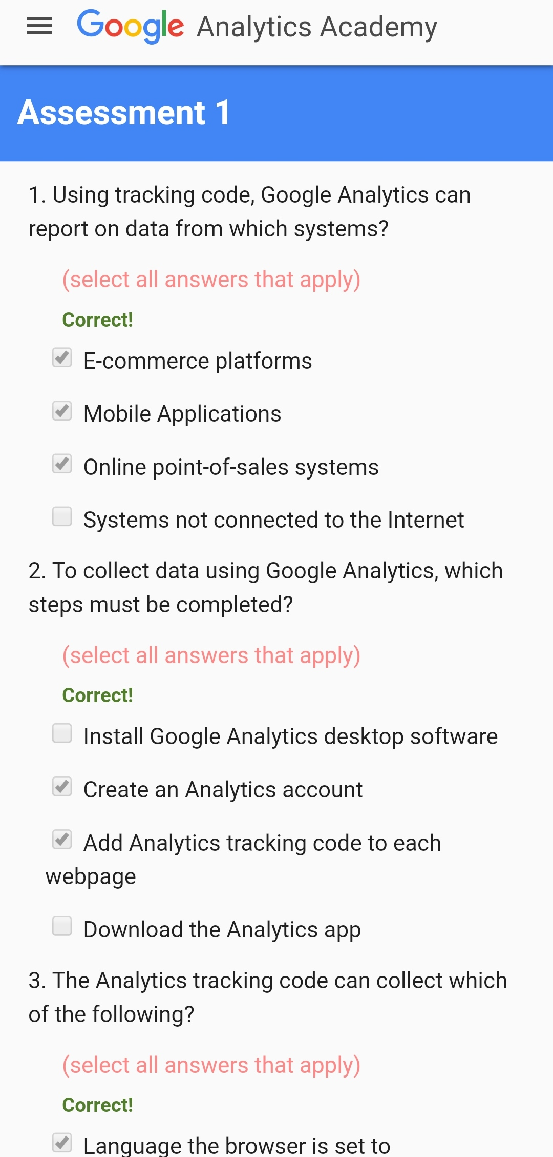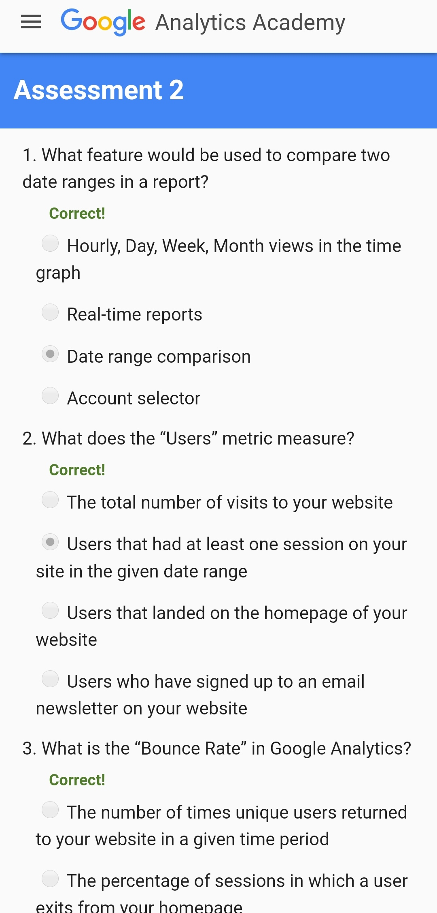

**Coding Challenges Details:**

Program 1: printing odd and even numbers from thread

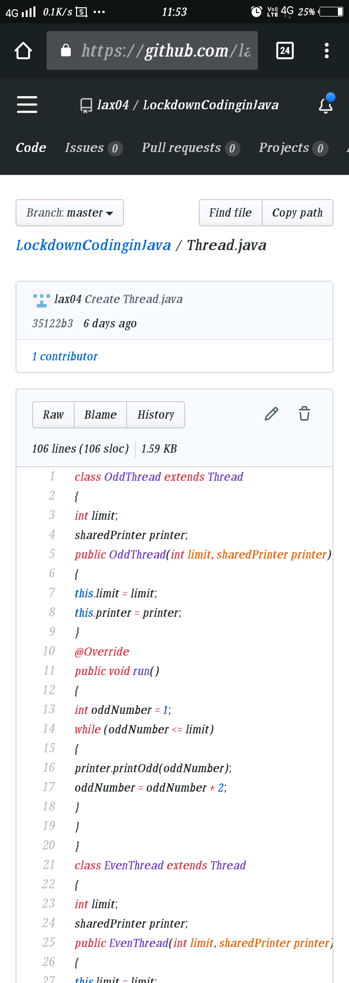

Program 2:We have a Letter or a word then we need add some letters to it and need to find out shortest palindrome  
For example we take "S": S will be the shortest palindrome string.  
If we take "xyz": zyxyz will be the shortest palindrome string  
So we need to add some characters to the given string or character and find out what will be the shortest palindrome string by using simple java program.

